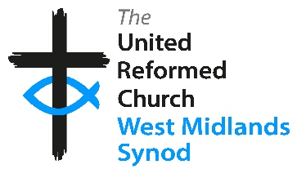
West Midlands Synod Eco Group
Energy Supply and Energy Efficiency survey
The Eco Group would like to gather some information about current arrangements for supply of gas and electricity to church buildings, as well as asking some questions about energy efficiency measures and future “greening” plans. Data will be held in accordance with the Synod Data Protection Privacy notice, to help us planning support for churches and as some anonymous statistical data to progress our accreditation as an Eco Synod. Personal data will not be shared with any third parties. Please complete this at the Synod Meeting if you have access to the answers, or take it back to your church and return it to the Synod Office by Friday 30th June. Thank you.
Church Name: _____________________________________________ Post code: ________________________
Your name: _______________________________________________ Email/phone no: _____________________________________________________
For each building with separate utility meters/supply (do not include Manses):
Building name | Name of electricity supplier | Are you on a “green” tariff? | Have you installed solar panels | Have you got double glazing? | Have you got secondary glazing? | Name of gas supplier  (Enter “N/A” if you do not use gas) | Are you on a “green” tariff? | Do you use heat pumps (Air Source of Ground Source)?
Church |  | Y / N | Y /N /  Not yet, but considering | Y / N /  On some windows | Y / N /  On some windows |  | Y / N | Y/ N /  Don’t know what they are / Not yet, but considering
Hall |  | Y / N | Y /N /  Not yet, but considering | Y / N /  On some windows | Y / N /  On some windows |  | Y / N | Y/ N /  Don’t know what they are / Not yet, but considering
Other (Enter name) |  | Y / N | Y /N /  Not yet, but considering | Y / N /  On some windows | Y / N /  On some windows |  | Y / N | Y/ N /  Don’t know what they are / Not yet, but considering
Other (Enter name) |  | Y / N | Y /N /  Not yet, but considering | Y / N /  On some windows | Y / N /  On some windows |  | Y / N | Y/ N /  Don’t know what they are / Not yet, but considering

Are you interested in knowing more about the Synod Energy Efficiency Grant scheme? Y / N / Already accessing the grant scheme
Any other comments you would like the Eco Group to hear? (continue overleaf)

