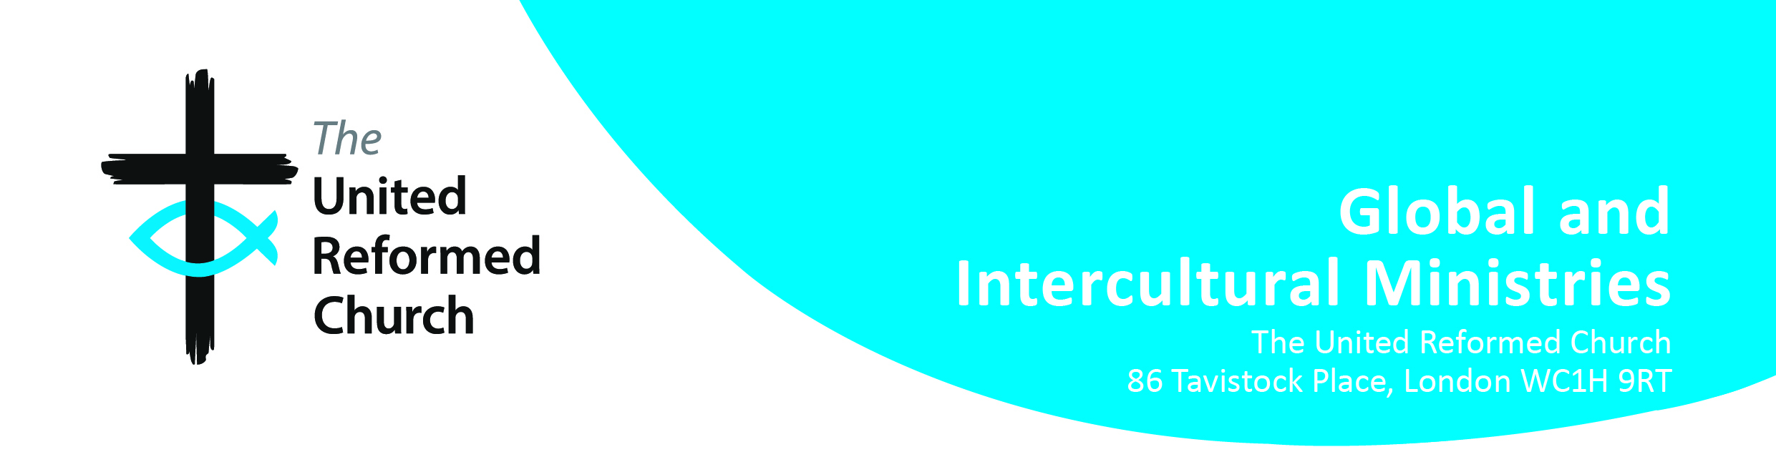
Belonging to the World Church
Application Form (BWC 4)

INTRODUCTION

You can apply for a Belonging to the World Church Grant (using the BWC 3 Form) if your annual or sabbatical leave includes an international experience. If you wish to seek BWC funds, you may need to weigh very carefully the necessity of your travel against certain criteria (see BWC 1 Form), particularly against the ability of the planet to cope with the resultant emissions. The carbon footprint of your travel will become part of BWC’s overall calculation to reduce carbon emissions to achieve net zero by 2030. Applications that involve lower carbon-modes of travel, such as trains, will naturally be given preference. Travel to Europe is by default by train unless there is a compelling reason to travel by other means. International travel by air may in some circumstances be unavoidable. But these applications must show the necessity and benefits of that travel given the BWC requirement to manage and reduce its carbon budget in compliance with General Assembly resolutions.

CONTEXT

In 2022 General Assembly resolved in the light of the injustice that is the climate emergency to take urgent action regarding the reduction of its own carbon emissions across the whole life of the church. The URC Environmental Policy identifies Travel and Transport as a key action area where carbon reduction strategies should be implemented. This means that Belonging to the World Church (BWC) must consider the necessity and benefits of all travel applications. It must take into consideration broader issues of justice, such as giving preference to lower carbon-modes of travel and manage a plan to reduce its carbon footprint to net zero by 2030.

BWC regards carbon offsetting as a last resort. Offsetting is an appropriate means of reparations for historical carbon emissions and not a justification for selecting carbon intensive travel. As all travel options will have some carbon impact, the cost of carbon offsetting will be an integral part of the grant (i.e. deducted from the grant).

The applicant is responsible for calculating the carbon offsetting amount. We recommend using https://www.climatestewards.org/carbon-calculators/ to work out the amounts. The Mission Team will then pay this amount from your grant first into the URC Trust account. For your information, Church House Trust accepts offsetting contributions that use the following reference:

Reference: ‘CARBON + SURNAME and INITIAL’. e.g. CARBONSMITHA or CARBONJONESB

Account: United Reformed Church Trust
Sort code: 40‐05‐03
Account Number: 01191802
IBAN: GB22HBUK40050301191802
BIC: HBUKGB4115N

BWC GRANT APPLICATION PROCESS

If you are considering applying for this grant, ask your Training Officer to contact Global and Intercultural Ministries (GIM) in the first instance to get an ‘in-principle’ agreement. This is to facilitate the oversight of the BWC annual carbon budget and reduction strategy. The EM3 applicant will be asked to
- Fill in the Balancing the Costs and Benefits (BWC 1 BCB) Form
- This together with the BWC Application Form (BWC 2) Form should be sent to your Training Officer. They can provide you with the appropriate forms. Your application should be signed off by the Training Officer who will send both forms to GIM. Both the grant applicant and Training Officer will be notified of the BWC decision. On your return, you will need to
- Fill in and email us (global.intercultural@urc.org.uk) your completed BWC-3 form within one month of your return to share your learning.

There are some important things worth remembering:

- The BWC grant is in addition to your normal EM3 grant
- For travel within Europe the BWC grant is up to an additional £750.00 provided there are no flights involved. Lower carbon forms of travel tend to be more costly and time intensive, and often requires additional overnight accommodation
- For travel beyond Europe that may be more carbon intensive, the maximum grant now is up to an additional £350.00
- You are entitled to one BWC grant every five years
- The BWC grant is to cover travel related expenses only, which over and above transport costs may include
- Visa fees and processing
- Immunisations
- Travel insurance
- Travel stop-over hotel costs (where necessary)
- Carbon Offsetting

MISSION TEAM

If you need the URC Mission Team to support you, please do not hesitate to ask.

We may be able to assist you by:

- Sharing why there is a pressing need to reduce carbon emissions
- Discussing possible experiences and programmes in different international locations
- Making initial contacts with our international church partners
- Helping with programme development

The Team may be able to help by making or signposting your travel arrangements. We may be able to offer you information on:

- The country you are travelling to (currency and exchange rate, weather, etc.)
- British Foreign Office information
- Heath information and immunisation requirements
- Visa forms
- Travel Insurance
- Risk assessments, particularly if you are travelling to a country experiences political and social unrest and military activity
- Contact telephone numbers in the United Kingdom in case of an emergency
- Things you should think about before, during and after your trip

We could also with your permission keep a document folder while you are travelling which will include photocopies of your immunisation record and the picture page of your passport, next of kin contact information and any other necessary information. This is primarily for a situation of emergency. Any documentation kept will be deleted once you have returned to the United Kingdom.

If you need further information about BWC, contact your Training Officer or the Mission Team – mission@urc.org.uk

Karen Campbell
Secretary for Global and Intercultural Ministries

Updated February 2023

