United Reformed Church West Midlands Synod
Policy on Authorised Elders for Lay Presidency at the Sacraments (Adopted Oct 2018)
SUMMARY
Following the introduction of “Authorised Elder” status for Lay Presidency at the sacraments, West Midlands Synod amends it policy of how lay presidents are to be authorised as follows. (This summary guidance is to aid understanding of the full detail of the policy, and it is the full detail that takes precedence in interpreting this policy. References in square brackets are to the relevant sections of the full policy.)
- Ordained Ministers of Word and Sacraments are preferred as presidents at the Sacraments. Retired and visiting ministers are not obliged to “stand in” as presidents, especially at short notice. [See Authorised Elders Policy (“AEP”) Introduction]
- If the previously arranged president becomes unavailable at short notice, the church may choose someone suitable to cover, or to postpone celebration of the Sacraments. [AEP 1]
- Normally those lay people allowed to preside at the Sacraments (“Authorised Elders”) will be Elders of the United Reformed Church (Serving or Non-Serving) and/or accredited lay preachers. The Synod interprets the latter to mean Assembly Accredited or Synod Recognised Lay Preachers who are members of the United Reformed Church (whether or not they have been ordained as Elders.) [AEP 2, Basis of Union 25]
- Churches will not have lay people authorised “just in case” the previously arranged president is not available. Those appointed as Authorised Elders will be expected to preside.
[AEP 2.2a]
- In order to authorise lay presidency, a church must establish that there is “pastoral necessity.” During a time of ministerial vacancy or sabbatical or long-term sick leave, Pastoral Committee will normally recognise that this pastoral necessity exists. [AEP 2.2a]
- For all other occasions, including if the church’s Minister is on annual leave, a church will need to explain why they believe it is appropriate for a Lay President to be appointed rather than postponing celebration of the Sacrament. [AEP 2.2a]
- Where a Minister is serving a church but on a limited scoping that might affect their availability to preside, a case for “pastoral necessity” might exist – all cases will be considered on their merits. The onus is on the local church to explain why they believe they need a Lay President. [AEP 2.2a]
- When a case of pastoral necessity has been recognised by the Pastoral Committee, usually not more than three Authorised Elders may be appointed for a church. [AEP 2.2a]
- Appointment follows approved training to a common standard, and lasts for up to three years. There are situations (such as a Minister being called) which might remove the pastoral necessity within the three year period. [AEP 2.2c]
- An Authorised Elder may be appointed for more than one church, but in each case there must be an established pastoral necessity for someone other than a Minister of Word and Sacraments to preside. [AEP 2.2d]
- Appointment as an Authorised Elder may be extended to second and subsequent periods of three years, providing the pastoral necessity still exists, and providing the Authorised Elder undergoes appropriate and approved refresher training. [AEP 2.2d]

Flowchart showing the processes involved to authorise Lay Presidency
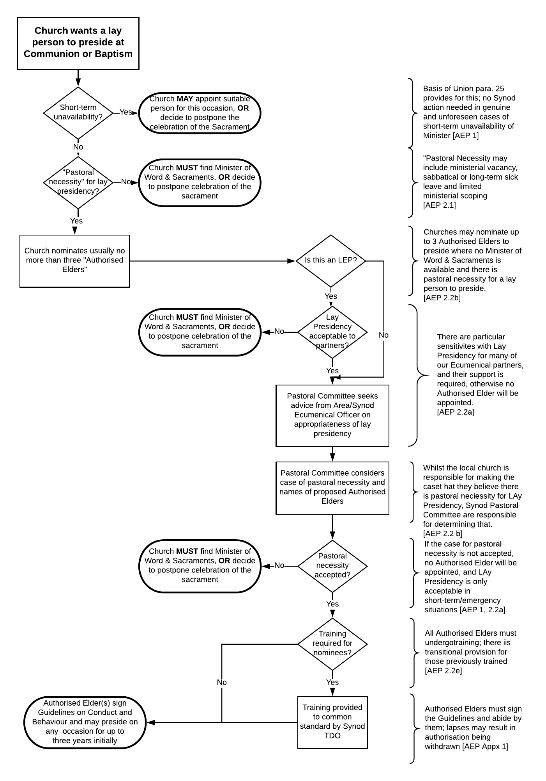
This flowchart summarises the Policy on Authorised Elders for Lay Presidency and is provided to aid understanding of the full policy. The full policy takes precedence in interpreting the policy, and references in square brackets are to the relevant sections of the policy.
United Reformed Church West Midlands Synod
Policy on Authorised Elders for Lay Presidency at the Sacraments (DRAFT May 2018)
POLICY DETAIL - INTRODUCTION
Following the decision taken at General Assembly 2016 on Authorised Elders (Resolutions 14-19) and the amendments to the guidance on Presidency at the Sacraments (Section F of the Manual), the West Midlands Synod notes that the normal pattern within the United Reformed Church is for those who have been prepared and ordained as Ministers of Word and Sacraments to preside at the Sacraments of Holy Communion and Baptism.
This means that churches should normally plan celebrations of the Sacraments around the availability of an Ordained Minister of Word and Sacraments (hereafter “Minister,” which includes Ministers of Word and Sacraments from Christian denominations other than the United Reformed Church). Churches need to give serious consideration to moving away from their fixed pattern of, for example, “the Third Sunday Morning of the month” for celebrating Communion if they cannot arrange for a Minister to be available with such regularity. For the avoidance of doubt, this policy applies to Baptism and to Communion. As Baptism is celebrated much less frequently than Communion it should in most cases be possible to arrange for those celebrations when a Minister can be present.
Churches are reminded that when a retired Minister is or is expected to be in the congregation, the United Reformed Church expects them to be invited to preside at the Sacraments, even if they have not been leading the rest of the worship. However, there is no obligation on them to preside if they indicate that they do not wish so to do. Similarly, if a serving Minister who does not hold pastoral charge within the congregation is present but is not otherwise involved in leading worship, they should be asked to preside but again there is no obligation upon them. This does not undermine the ministry exercised by any lay person, whether they are an Assembly Accredited or Synod-Recognised Lay Preacher or anyone else. Presidency at the Sacraments is not a matter of status or competence but of good order, and might be understood as a pastoral rather than a preaching ministry (hence provision for the appointment of Authorised Elders). Further, it should be recognised as good practice for a Minister of Word and Sacraments to be the normal President, both for honouring the calling of the Minister, and for involving a variety of people in the worship of God in a fitting and orderly way (cp. 1 Cor 14:26-33, 40; also, the word “liturgy” comes from Greek words meaning “the work of the people”. Worship involves effort on the part of all of God’s people, not just one.)
However, both General Assembly and the West Midlands Synod recognise that at times it will not be possible for a Minister to preside at the Sacraments. Such occasions fall into two categories:
- Short-notice unavailability
- Unavailability recognised ahead of time.
- Short-notice unavailability of a Minister to preside
This is the situation where the planned President (Minister or Authorised Elder) is taken ill in the day or two before the service, or is unavoidably detained on the way to church (family emergency, difficulties with transport, etc.), and it is neither reasonable nor possible to find a Minister or Authorised Elder to take their place at such notice. In such cases, a church has two options:
- Postpone the celebration of the Sacrament until such time as a properly authorised President (Minister or Authorised Elder) can be present.
- Agree for a member of the congregation to preside. The guidance in the Basis of Union (§25) says, “The provisions of paragraph 25 are intended to establish the principle that worship should be led by representative persons recognised by the wider church as well as by the local church. The provisions do not prevent the congregation assembled for baptismal or communion service from themselves appointing, as a church meeting, a suitable person to preside at the celebration of the Sacrament in a case of emergency, for example if the expected president is taken ill or held up in travel. The provisions do not require such an action rather than a postponement of the baptismal or communion service if that seems preferable. ”

Wherever possible the person appointed should be someone experienced and/or trained for Lay Presidency, but in any case they must be acceptable to the congregation. Churches may agree ahead of time (perhaps annually) who might be asked to preside at such short notice, but there is no obligation for churches to agree a “just-in-case” Lay President. As a matter of practice, a local church might agree that the Elders should make a decision on the morning itself, but in this case it would be appropriate to make that clear at the outset of the worship so that everyone present understands the situation (and can therefore choose whether to share in the Sacrament if they find Lay Presidency difficult. Alternatively, permission may be sought from the gathered congregation for permission for a particular person to preside.

- Planned unavailability
This is the situation where it is known with reasonable notice that no Minister is available to preside. This might typically be due to annual or sabbatical leave for a Minister, or a vacancy in ministry. As stated above it is possible and may be considered desirable to alter the planned date for the celebration of the Sacrament until such time as a Minister is available.
  - Provision for Lay Presidency
However, the Basis of Union (§25) and Resolution 14(b) of General Assembly 2016 makes provision for others to preside if “the Minister in pastoral charge is not available.” That resolution says, “the Church Meeting may invite an elder (or accredited lay preacher) authorised by the synod, in accordance with the provisions of §25 of the Basis of Union: elders of the local church and accredited lay preachers regularly conducting worship there should be considered first.” The relevant paragraph of the Basis of Union says, “The worship of the local church is an expression of the worship of the whole people of God. In order that this may be clearly seen, the United Reformed Church shall… make provision through synods, in full consultation with the local churches concerned, for the recognition of certain members of the United Reformed Church, normally deaconesses, elders or accredited lay preachers, who may be invited by local churches to preside at baptismal and communion services where pastoral necessity so requires. The pastoral needs of each situation shall be reviewed periodically by the synod in consultation with the local church. Apart from ordained ministers of the United Reformed Church and of other churches, only such recognised persons may be invited.”
  - Process to appoint Authorised Elders
- Establishing a need. Under the revised guidance in Section F, it is for each church (through its Church Meeting or equivalent council in Local Ecumenical Partnerships) to determine when they believe that cases of “pastoral necessity” apply and so presidency by an Authorised Elder might be appropriate. They shall then seek the approval of Synod Pastoral Committee (through their Area Minister or the Synod Office) that “pastoral necessity” does apply. Particular sensitivity is required in the cases of Local Ecumenical Partnerships, where many of our ecumenical partners do not allow or make no provision for Lay Presidency. Advice should always be sought from the Area Minister, Ecumenical Officers, or denominational partners in such cases.
Unless there are exceptional circumstances, no more than three Authorised Elders will be approved for any particular church. Authorised Elders shall only be appointed where the “pastoral necessity” case has been made, and there is therefore a clear expectation that Authorised Elders shall actually preside during the term of their authorisation. If there is no need for them to preside, they shall not be given authorisation. (This does not affect the provisions under paragraph 1 above for emergency/short-notice approval by the local church.) It is recognised that within the three year authorisation period, the circumstances of the church may change so that “pastoral necessity” for lay presidency no longer applies. Calling a Minister to the church is one example where this might apply. Pastoral Committee will keep the need to lay presidency under review and may, if circumstances warrant it, end the appointment of the Authorised Elder(s) before then end of the three year period.
Where an Elder in Local Leadership is appointed to a church, the case of “pastoral necessity” for that person to be available to preside at the Sacraments at that church will be received favourably, but these individuals will still need to go through the usual training and appointment route given below.
- Nominating Authorised Elders. When Synod Pastoral Committee accepts that there is a case of “pastoral necessity” that warrants the appointment of one or more Authorised Elders, the church is responsible for nominating appropriate individuals for this role. Resolution 14/2016 requires that the nominated Authorised Elder should normally be an Elder of that local church or an accredited lay preacher who “regularly” conducts worship there.
Nominations shall be submitted to the Area Minister where one is in post or to the Moderator’s PA for consideration at the next meeting of the Pastoral Committee. Churches are therefore required to consider the need for lay presidency in good time, and not abuse the provision of section 1 above regarding short notice unavailability which applies only when it could not have reasonably been foreseen that no Minister of Word & Sacraments or other previously-authorised President would be available.
Authorised Elders will not be permitted to preside at the Sacraments until such time as Pastoral Committee has authorised them, they have undergone appropriate training, and have signed the Guidelines and Conduct on Behaviour as described below.
- Training individuals as Authorised Elders. Training and preparation shall be carried out to the denominationally-agreed syllabus, and usually at the direction of the Synod Training and Development Officer. On occasion, this training may be delegated to other suitable people, but the same standards are required.
In meeting the requirements of §25 of the Basis of Union, the Synod shall determine who is suitable to become an Authorised Elder. Suitable people shall be required to undergo training, including refresher training at intervals of not more than three years in order to gain and retain authorisation. In the light of the representative and responsible nature of the role, they shall also be required to sign a copy of the Guidelines on Conduct and Behaviour for Authorised Elders (see Appendix 1 below) and act in accordance with it at all times during their period of authorisation.
Once a church has received confirmation of the appointment of an Authorised Elder for their congregation, they do not need further permission for that Authorised Elder to preside at the Sacraments on any particular occasion within the period of their authorisation. The church is free to use that Authorised Elder whenever they deem it appropriate throughout that period, bearing in mind that Ministers should always be invited to preside where possible.
- Limitations on authorisation. Authorised Elders are appointed for particular congregations or, where circumstances warrant it, all churches within a particular pastorate. They may be given authorisation to preside at several different congregations and pastorates within the Synod. It is not appropriate for authorisation to be given to an individual for all churches within the Synod because the pastoral necessity for lay presidency in every church cannot be established.
If an Authorised Elder has undergone training for only one of the Sacraments they can be authorised to preside at that particular Sacrament and not the other until they have been trained and authorised for the other.
The Synod retains the right to remove authorisation from any individual at any point and if necessary pass their name to the General Secretary in accordance with Resolution 17 of Assembly 2016, to prevent those who have exercised a ministry of Authorised Elder unhelpfully doing so again in other places. Without current authorisation a person who was previously an Authorised Elder shall not be permitted to preside at the Sacraments, except when approved by a local church under the provisions for short-notice unavailability in paragraph 1 above.
On first appointment (but see also paragraph (d) below) Authorised Elders shall serve a probationary year. Positive affirmation from the local church shall be required to extend the term of authorisation beyond the probationary year. Authorised Elders shall then be authorised to serve congregations for terms of up to three years.
Authorised Elder status may be given to individuals for second and subsequent terms upon (1) support from the local church being given to the Synod, (2) the Synod determining that there is still pastoral necessity for the authorisation, (3) the individual completing refresher training as provided by the Synod and (4) the individual otherwise meeting the requirements identified in the Guidelines on Conduct and Behaviour in Appendix 1.
- “Grandparent” rights. Where an individual who is not a Minister has previously been authorised to preside at the Sacraments for a church and has already undergone appropriate training, they may be appointed an Authorised Elder in that or another church, provided that (1) the church presents a satisfactory case of “pastoral necessity,” (2) the church or pastorate asks for the individual to become an Authorised Elder for the church or pastorate, (3) the individual signs and abides by the Guidelines on Conduct and Behaviour in Appendix 1 below.
This “inherited” status shall apply for a maximum of three years, after which the individual must complete refresher training as provided and according to the denominationally-agreed syllabus before authorisation for a further term can be considered.

Appendix 1
Guidelines on Conduct and Behaviour for authorised elders
(Approved at Mission Council, March 2018)
Introduction
In 2016 the General Assembly agreed that the pattern of presidency at the sacraments if the minister in pastoral charge is not available should be as follows:
- The Church Meeting may invite another Minister of Word and Sacraments
- If such a minister is not available, the Church Meeting may invite an elder (or accredited lay preacher) authorised by the synod, in accordance with the provisions of §25 of the Basis of Union: elders of the local church and accredited lay preachers regularly conducting worship there should be considered first
- Authorisation for such presidency by the synod, normally of members from within the congregation concerned, should be for an initial period of three to five years (according to synod judgement), including a probationary year on first appointment, with the possibility of renewal. Before renewal there should be consultation by the synod with the congregation, and a review of its needs.
Authorised Elders in this document refers to those appointed by the synod under 2 above, whether elders or lay preachers. Such appointees agree to abide by these guidelines on conduct and behaviour.
Faithful living
Those appointed will take account of the need to model a Christian lifestyle including:
- Live a Christian life as persons of prayer and integrity
- Be committed to growing in faith and discipleship and developing the gifts each has been given
- Avoid doing anything to undermine the spiritual health of another
- Regard all persons with equal respect and concern and not discriminate against anyone on the basis of gender, race, age, disability or sexual orientation
- Refrain from using privilege or power for personal advantage or gain, whether financial, emotional, sexual or material
- Work collaboratively with ministers/CRCWs, elders, members and lay preachers where appropriate
- Seek advice from others if in doubt about one's competence to deal with any issue or situation
- Engage positively with all the councils of the church.
Authorised elders will:
- Remember that the worship of the local church is an expression of the worship of the whole people of God
- Treat honourably the traditions and practices of the United Reformed Church
- Be sensitive to the particular patterns of worship life in the congregation for which they are authorized
- Undertake such training as determined by the synod in line with the requirements of General Assembly
- Engage positively with the review process at the end of the probationary year and at the end of the appointment period
- Hold a valid Disclosure and Barring Service certificate or comply with an alternative Ministries Office disclosure process where this is not possible
- Be supportive of any changes the church and synod may wish to make at the end of the appointment, recognising that changes within the pastorate may mean there is no ongoing need for an authorised elder or that it is appropriate for someone else to take on the role.

I agree to uphold the standards contained within these Guidelines on Conduct and Behaviour for Authorised Elders and will conduct my ministry accordingly.

Signed: _______________________________________________ Date: ____________________

Name (PRINT): ___________________________________________________________________

The person named above has been designated as an “Authorised Elder” by the West Midlands Synod Pastoral Committee for the following church(es)/pastorate(s):

________________________________________________________________________________

Signed on behalf of Pastoral Committee: ______________________________________________

Date of authorisation: _____________________________________________________________

